**2-TIER APPLICATION (FRONTEND, BACKEND & DATABASE)**

1. **CREATE A NEW FOLDER ‘DevOps’**
2. **CREATE ANOTHER FOLDER INSIDE DevOps NAMED AS PUBLIC**
3. **INSIDE PUBLIC – CREATE AN INDEX.HTML FILE (CHECK CODE IN THE FOLDER)**
4. **GO TO TERMINAL & INSTALL NECESSARY PACKAGES**

mkdir contact-form

cd contact-form

npm init -y

npm install express body-parser sqlite3

1. **INSIDE DevOps FOLDER, CREATE A SERVER.JS FILE (CHECK CODE IN THE FOLDER)**
2. **GO TO THE TERMINAL, NAVIGATE TO THE DIRECTORY AND TYPE**

npm install express body-parser sqlite3

node server.js

1. **NAVIGATE TO http://localhost:3000 IN YOUR BROWSER TO SEE THE FORM. WHEN YOU SUBMIT THE FORM, THE DATA WILL BE SAVED IN THE SQLITE DATABASE.**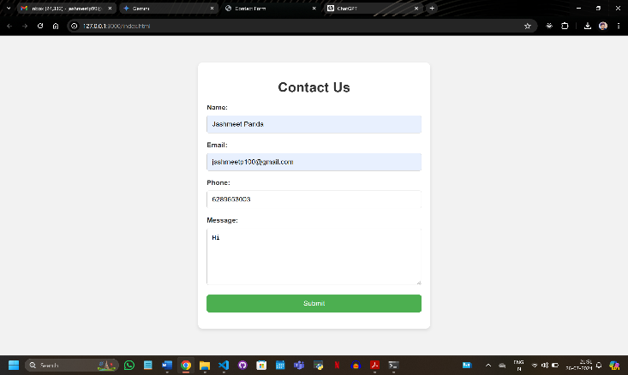
2. **ENSURE YOUR PROJECT STRUCTURE IS AS FOLLOWS:**

**g**

DevOps > node modules

> package.json

> server.js

> public –> index.html

**D**

1. **GO TO THE TERMINAL AND NAVIGATE TO THE DIRECTORY AND TYPE:**

sqlite3 contacts.db

sqlite> .tables

sqlite> select * from contacts;

1. **DETAILS THAT YOU ENTERED IN THE FORM WILL BE DISPLAYED AS THE OUTPUT IN THE FORM OF ROWS.**

